**Exercise 1: MYFIRSTREACT**

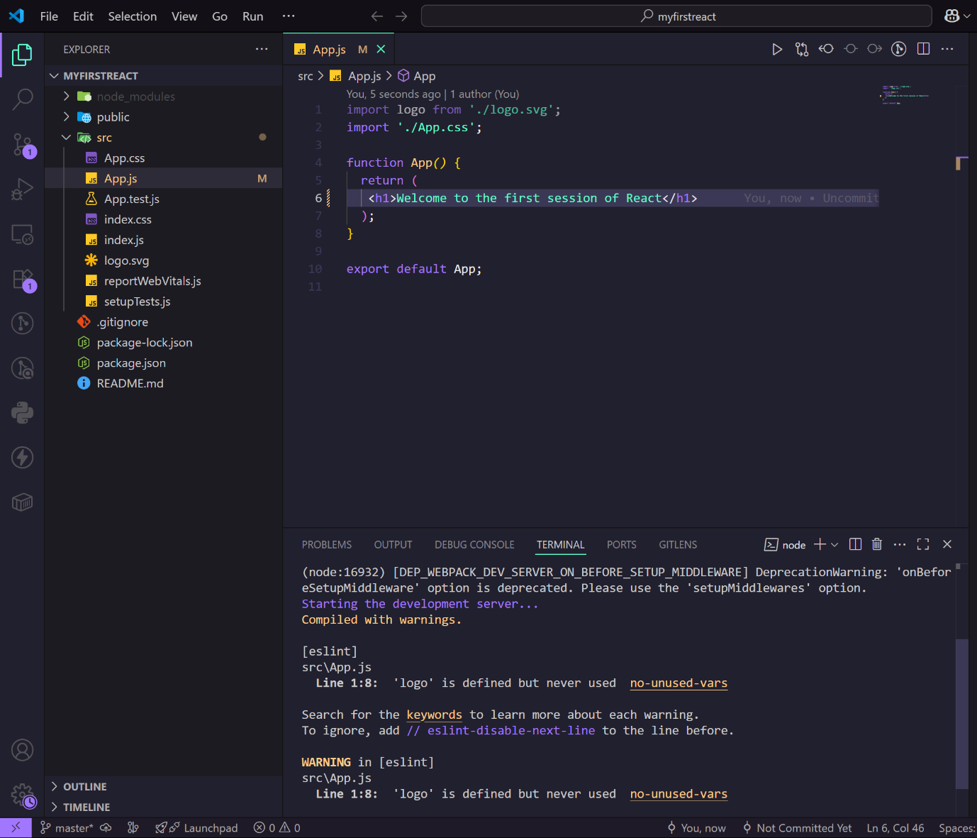

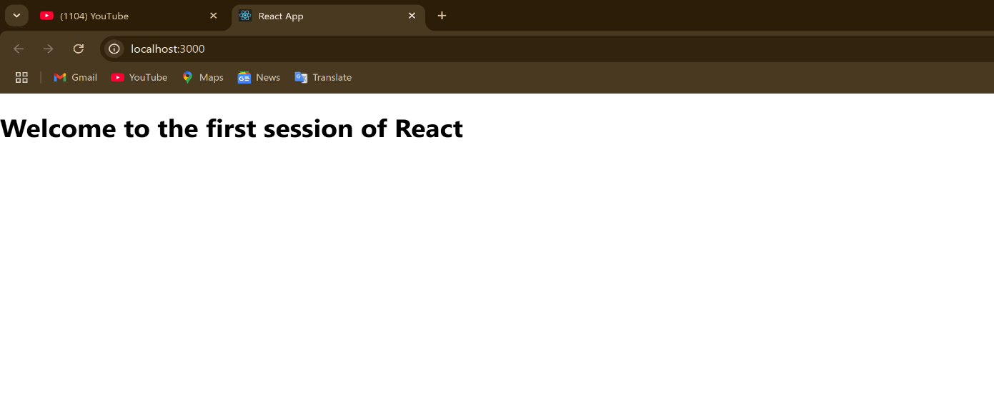

**Exercise 2: StudentApp**

**Code:**

**File:./Components/Home.js**

import React,{Component} from "react";

export class Home extends Component {

  render*()* {

    return (

      <div>

        <h3>Welcome to the HomePage of Student Management Portal</h3>

      </div>

    );

  }

}

**File:./Components/About.js**

import React,{Component} from "react";

export class About extends Component {

  render*()* {

    return (

      <div>

        <h3>Welcome to the AboutPage of Student Management Portal</h3>

      </div>

    );

  }

}

**File:./Components/Contact.js**

import React,{Component} from "react";

export class Contact extends Component {

  render*()* {

    return (

      <div>

        <h3>Welcome to the ContactPage of Student Management Portal</h3>

      </div>

    );

  }

}

**File:App.js**

import './App.css';

import { Home } from './components/Home';

import { About } from './components/About';

import { Contact } from './components/Contact';

function App*()* {

  return (

    <div className="container">

      <Home />

      <About />

      <Contact />

    </div>

  );

}

export default App;

**Output:**

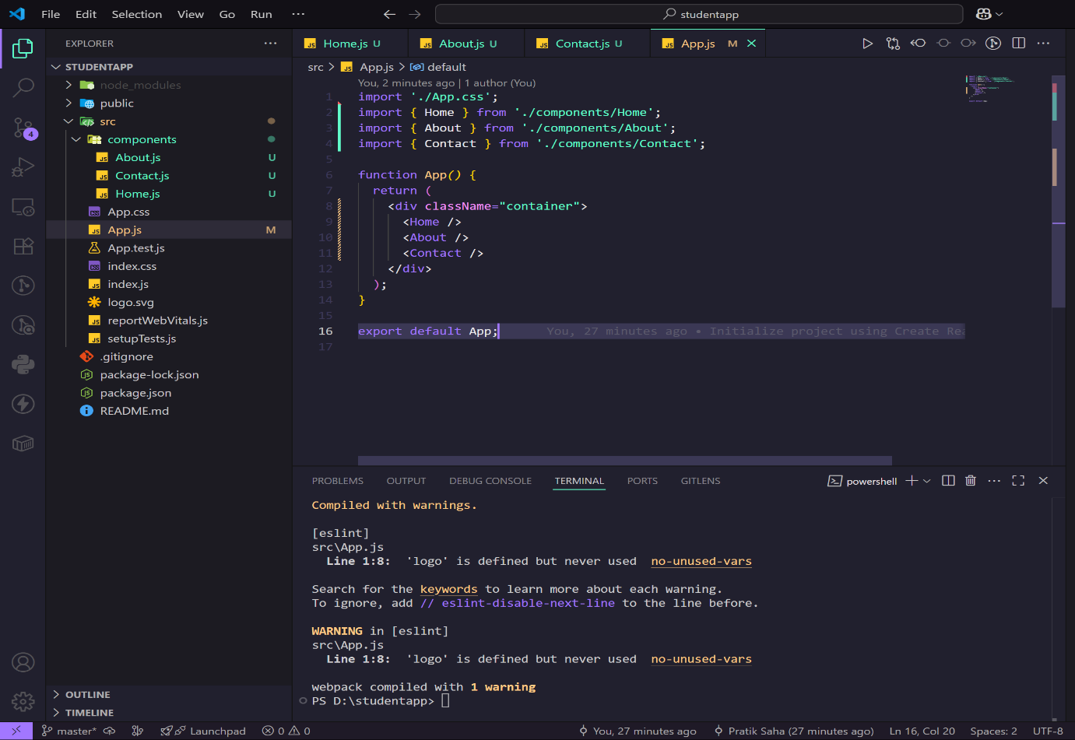

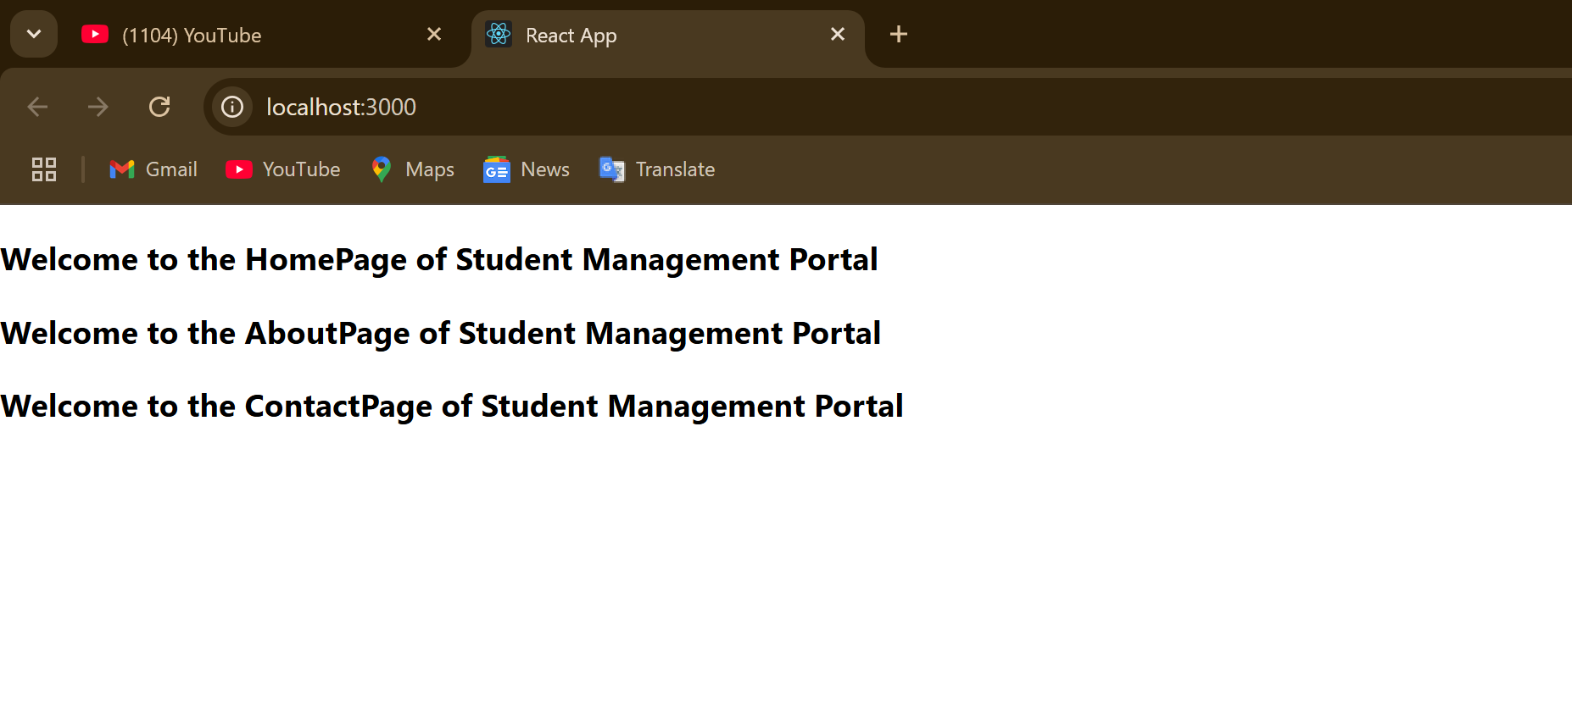

**Exercise 3: ScoreCalculatorApp**

**Code:**

**File:./components/calculatescore.js**

import '../stylesheets/mystyle.css';

const percentToDecimal=*(decimal)*=>{

    return (decimal.toFixed(2)+'%')

}

const calcScore=*(total,goal)*=>{

    return percentToDecimal(total/goal)

}

export const CalculateScore = *({Name,School,total,goal})*=>{

    return (

    <div className='formatstyle'>

        <h1><font color="Brown">Student Details</font></h1>

        <div className='Name'>

            <b><span>{Name}</span></b>

        </div>

        <div className='School'>

            <b><span>School:</span></b>

            <span>{School}</span>

        </div>

        <div className='Total'>

            <b><span>Total:</span></b>

            <span>{total}</span>

            <span>Marks</span>

        </div>

        <div className='Score'>

            <b>Score:</b>

            <span>{calcScore(total,goal)}</span>

        </div>

    </div>

    );

}

**File:App.js**

import "./App.css";

import { CalculateScore } from "./components/calculatescore";

function App*()* {

  return (

    <div>

      <CalculateScore

        Name={"Steeve"}

        School={"DNV Public School"}

        total={284}

        goal={3}

      />

    </div>

  );

}

export default App;

**File:./stylesheets/mystyle.css**

/* Removed invalid import statement */

.Name

{

    font-weight: 300;

    color: blue;

}

.School

{

    color: crimson;

}

.Total

{

    color: darkmagenta;

}

.formatstyle

{

    text-align: center;

    font-size: large;

}

.Score

{

    color: forestgreen;

}

**Output:**

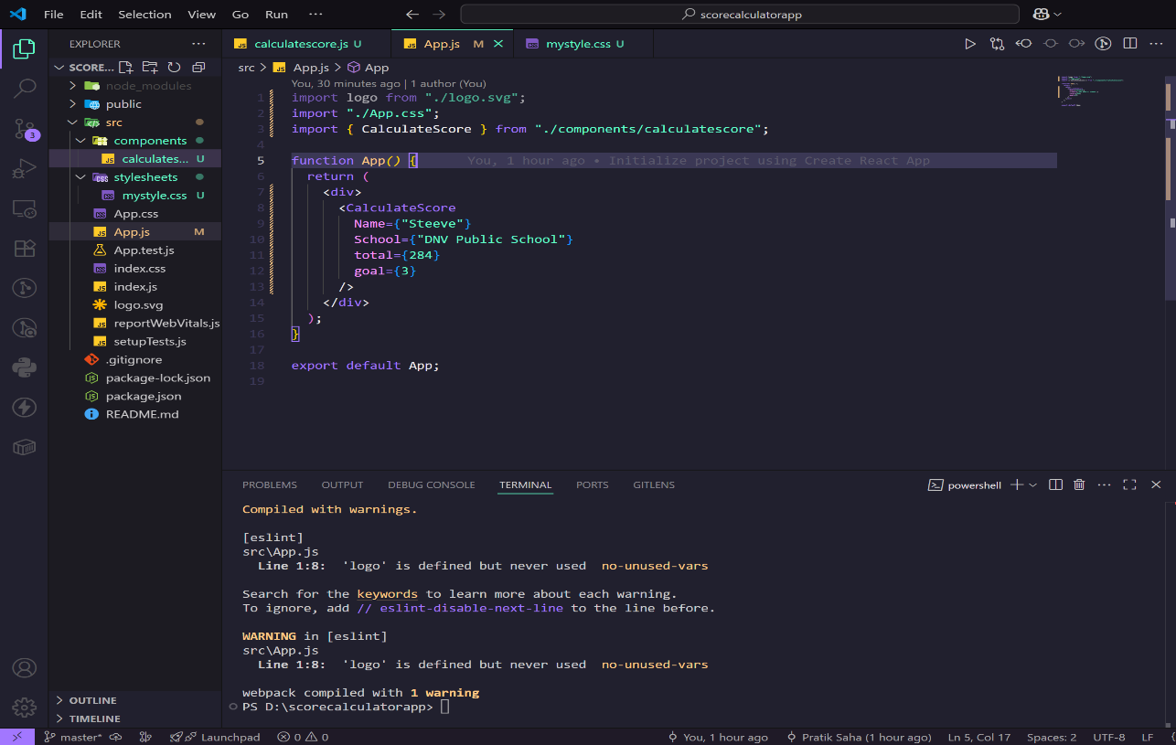

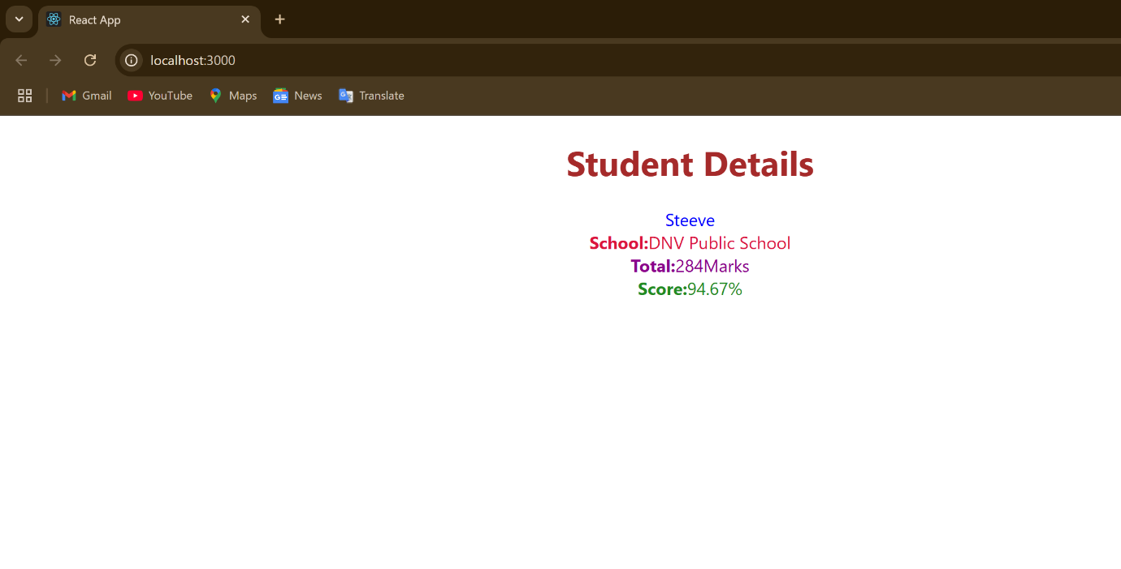

**Exercise 4:BlogApp**

**Code:**

**FileName:Post.js**

class Post{

    constructor*(id,title,body)*{

        this.id = id;

        this.title = title;

        this.body = body;

    }

}

export default Post;

**FileName:Posts.js**

import React from 'react';

class Posts extends React.Component{

    constructor*(props)*{

        super(props);

        this.state = {

            posts: []

        };

    }

  loadPosts = *()* => {

    fetch('https://jsonplaceholder.typicode.com/posts')

      .then(response => response.json())

      .then(data => {

        this.setState({ posts: data });

      })

      .catch(error => {

        console.error('Error fetching posts:', error);

        alert('Failed to fetch posts');

      });

  };

  componentDidMount*()* {

    this.loadPosts();

  }

  componentDidCatch*(error, info)* {

    alert("An error occurred: " + error);

    console.error('Error info:', info);

  }

  render*()* {

    return (

      <div>

        <h1>All Posts</h1>

        {this.state.posts.map(post => (

          <div key={post.id} style={{ marginBottom: '20px' }}>

            <h2>{post.title}</h2>

            <p>{post.body}</p>

          </div>

        ))}

      </div>

    );

  }

}

export default Posts;

**FileName:App.js**

import './App.css';

import Posts from './Posts';

function App*()* {

  return (

    <div className='App'>

      <Posts />

    </div>

  );

}

export default App;

**Output:**

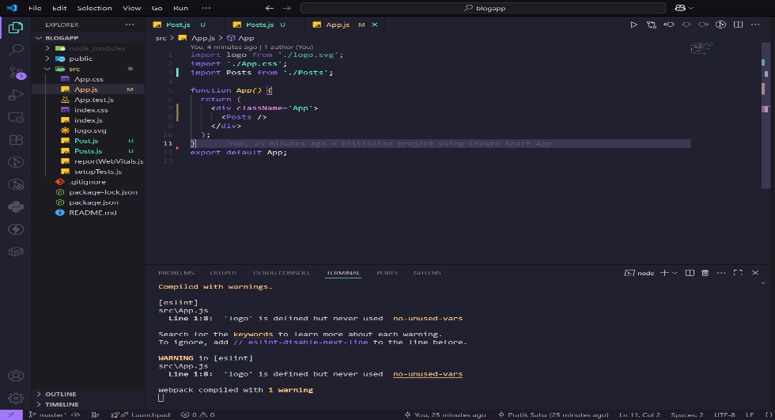

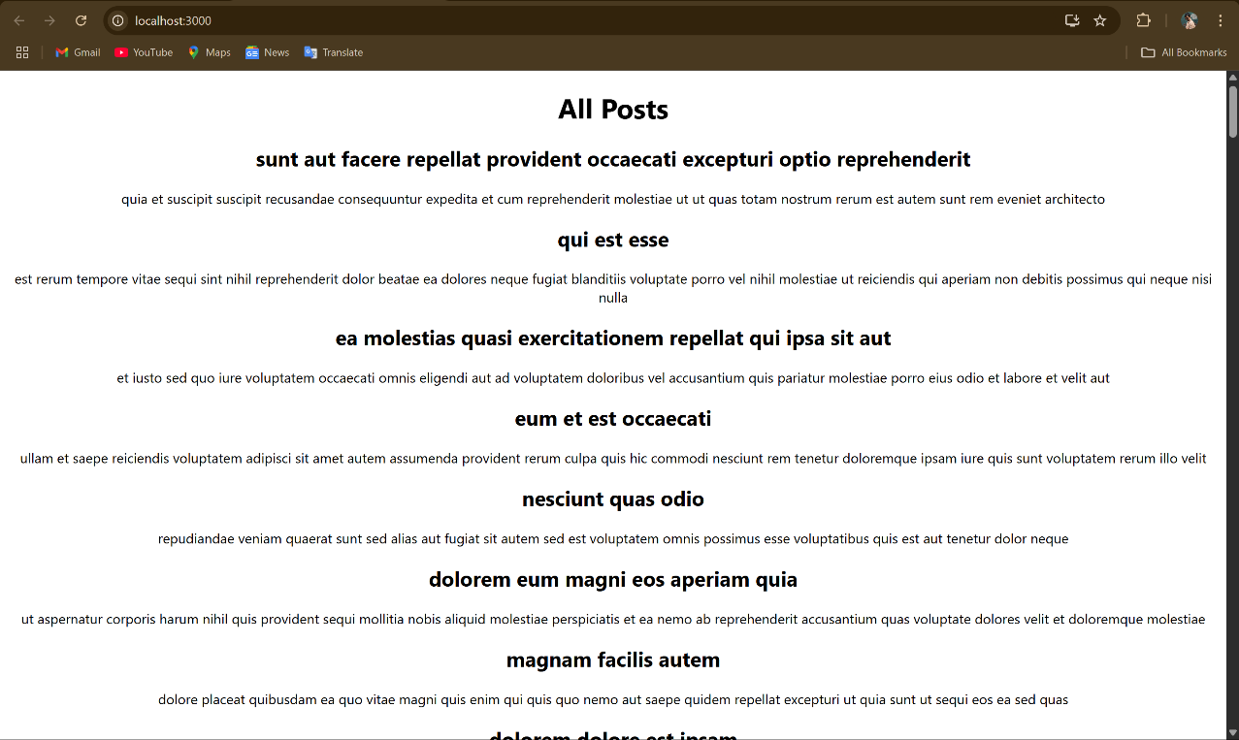

**Exercise 5:Cohorttracker**

**Code:**

**File:CohortDetails.module.css**

.box {

  width: 300px;

  display: inline-block;

  margin: 10px;

  padding: 10px 20px;

  border: 1px solid black;

  border-radius: 10px;

}

dt {

  font-weight: 500;

}

**File:CohortDetails.js**

import styles from './CohortDetails.module.css';

function CohortDetails*(props)* {

    return (

        <div className={styles.box}>

            <h3 style={{ color: props.cohort.currentStatus === 'ongoing' ? 'green' : 'blue' }}>

                {props.cohort.cohortCode} -

                <span>{props.cohort.technology}</span>

            </h3>

            <dl>

                <dt>Started On</dt>

                <dd>{props.cohort.startDate}</dd>

                <dt>Current Status</dt>

                <dd>{props.cohort.currentStatus}</dd>

                <dt>Coach</dt>

                <dd>{props.cohort.coachName}</dd>

                <dt>Trainer</dt>

                <dd>{props.cohort.trainerName}</dd>

            </dl>

        </div>

    );

}

export default CohortDetails;

**Output:**

